HASH TABLE ASSIGNMENT

Mandatory

- Refer the example code of hashtable in socodery. Implement the additional functions below.
- Test the program with a sample input file with data below
C Programming
Data Structure and Algorithms
Computer System
CProgramming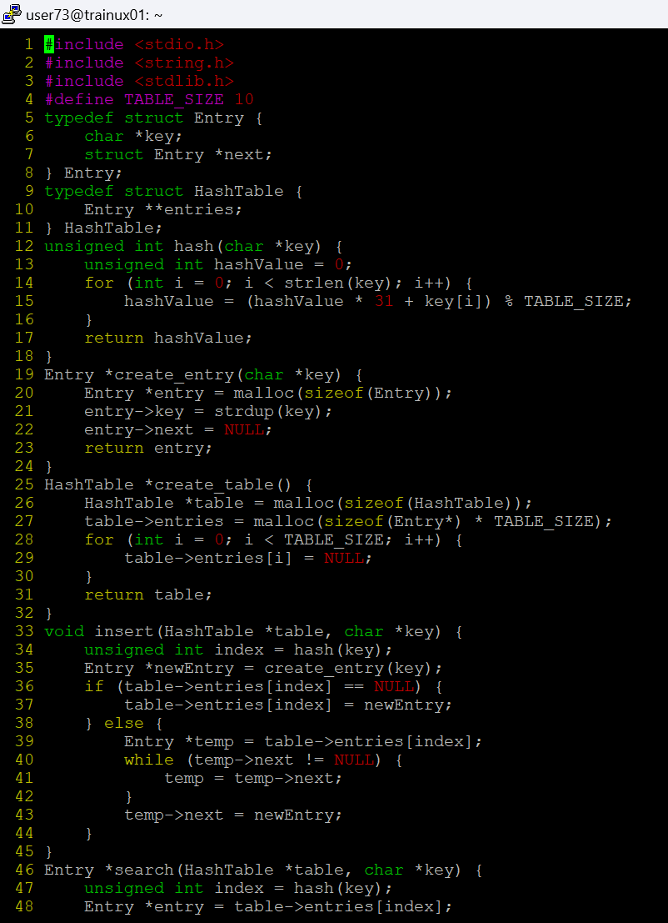
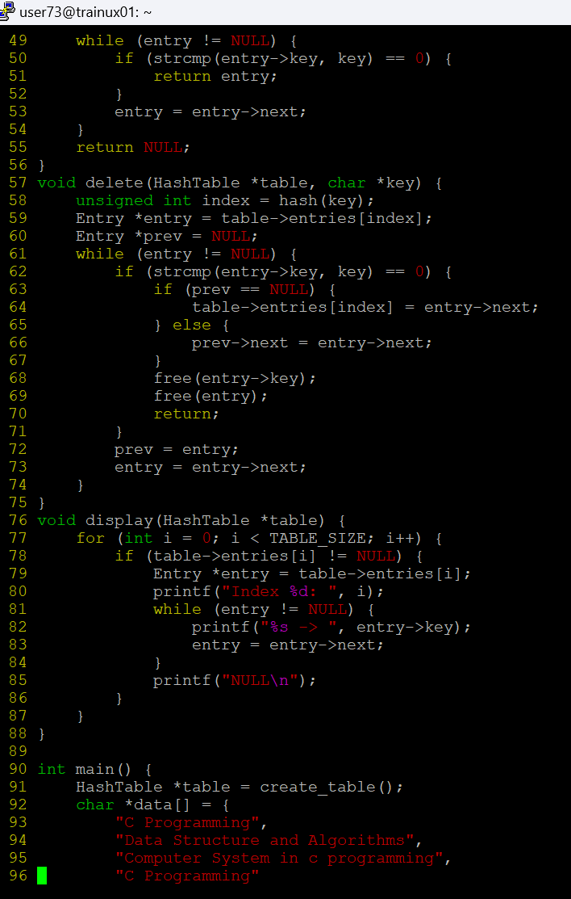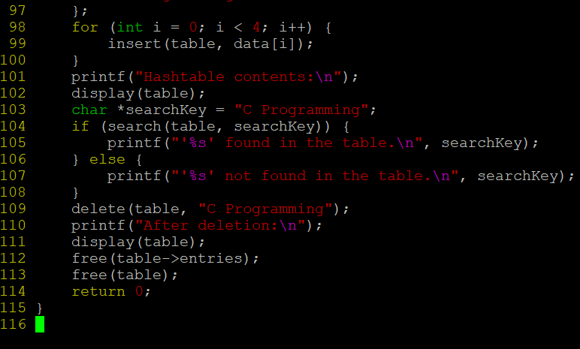
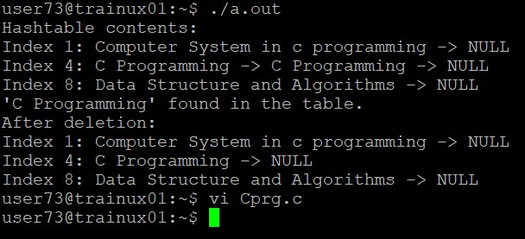

- Traverse and display the hash table contents. How many entries are stored in hash table? Is this same as input? Justify the answer with reasons?
The hash table stores 5 entries due to the insertion of a duplicate entry ("C Programming") from the input. This is not the same as the input, which had only 4 unique entries.

- Which type of collision mechanism is used in code?
The collision mechanism used in the code is chaining, where each index in the hash table stores a linked list of entries. When multiple entries hash to the same index, they are added to the linked list at that index.

- Modify the hash_function() such that for input string “Computer System” return the index of string “Data Structure and Algorithms”. Let this modification be controlled using a compile time flag below which can be enabled or disabled
#define ENABLE HASHFUNC_STUB

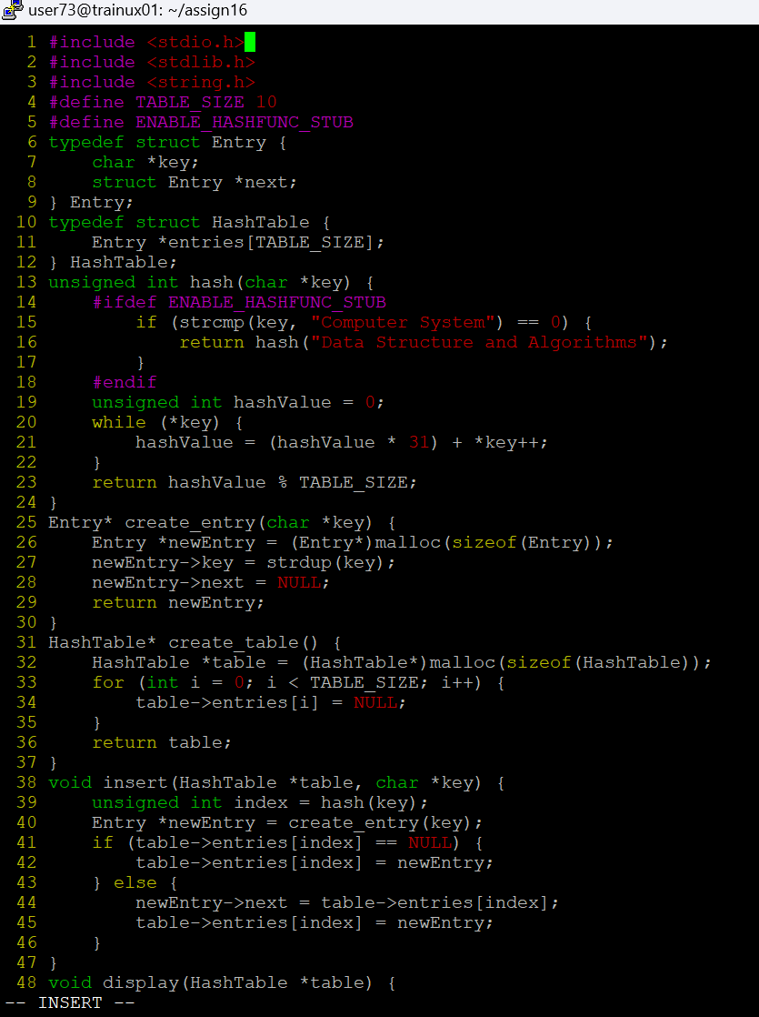
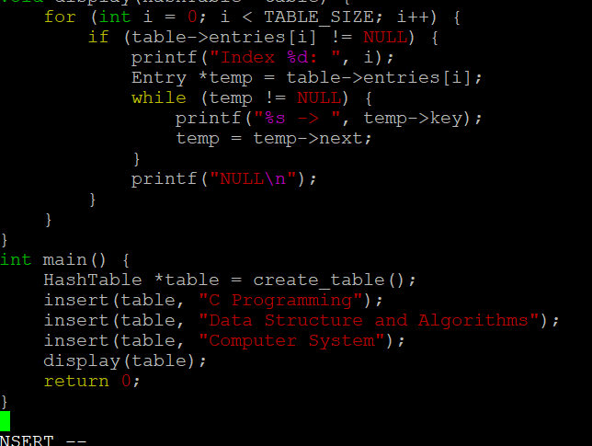

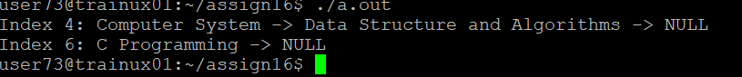
- Implement a hash table to read a list of strings from the user as command line argument, store each string in hashtable, count their frequency and display them. Use name as hash key and frequency as value. Implement below functions.
int hash(char *str);
int add_to_hash(char *str, int key);
int get_frequency(char *str);

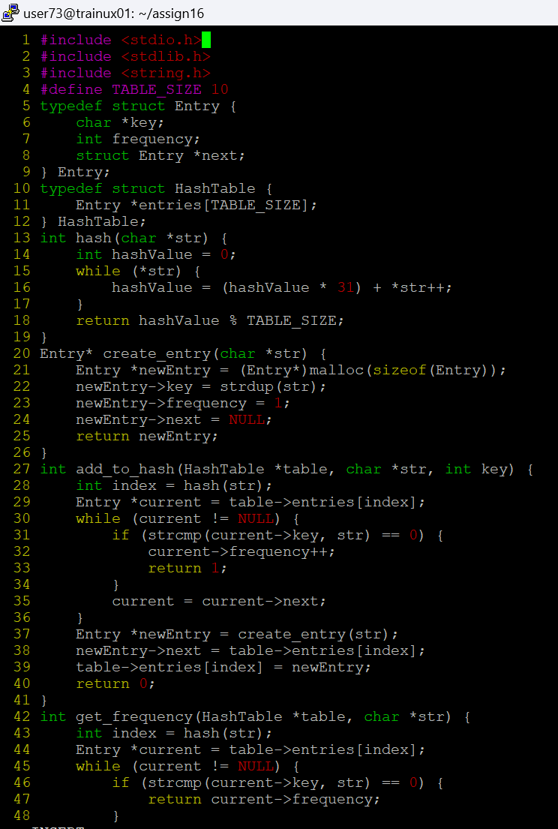
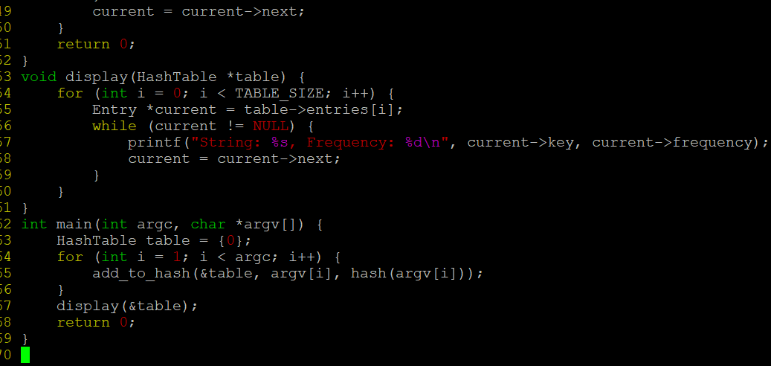

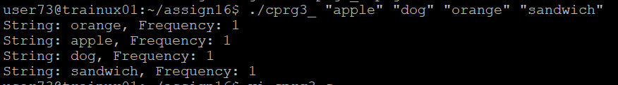
Add anyother required function. Test your solution with input dataset below
“Cprogram,CPPProgram,Cprogram,CPPProgram,Pascal”

